GBT Configuration: Requirements and Algorithms
by F. Ghigo and R. Maddalena,
April 9, 2003
(Section 6 revised September 25, 2003)

1.0 Introduction
Configuring the GBT system can be a bewildering task. Setting many switches, filters, frequencies, and other options must be done correctly for successful astronomical observations. The purpose of this document is to present a set of astronomer-friendly keywords, and to specify how they are used to configure the system.
There is a distinction between configuring and observing. In general a configuration remains fixed during a series of observations. Observing procedures direct the antenna to move in various ways, running procedures such as 'track', 'peak', 'onoff', etc. From one scan to the next, certain parameters may change, such as the antenna tracking position, velocity, and receiver tuning frequency. Most other parameters, such as number of spectral windows, filter settings, and backend bandwidth, will stay the same. This document will only discuss configuring, not balancing or observing processes.

1.1 Keywords
We first list the primary and secondary keywords required to completely configure the GBT, and provide default values. Table 1 lists the primary keywords (or meta-parameters) that are required and have no default values. Table 2 lists primary keywords for which reasonable default values exist. Note that in many cases, possible values of a keyword depend on the type of backend or observing type. Following that are secondary keywords (Section 3) that specify options that are specific to particular receivers or back ends.

1.2 Implementation
Following the tables is a discussion of how each keyword value can be implemented (Section 4). A dependency diagram (Section 5) shows how values of keywords may depend on the choices of more basic keywords. Section 6 provides instructions for calculating the LO1, LO2, and RF or IF bandwidths. Wiring the system, connecting the signal paths from receiver to back end, is discussed in Section 7.
The implementation software will consult the cabling file to trace connections through the system. We propose to introduce a ‘quality’ factor for every hardware module that will indicate which modules are substandard or out of service.
The Appendix gives details for implementation from the point of view of the YGOR manager parameters.

1.3 Configuration vs. Tweaking
Previous discussions have distinguished between the configuration and "tweaking" phases of experiment setups. After careful consideration and experience, it now seems that we cannot break apart these two steps. In too many cases a configuration step for one observer is another observer’s tweak.
The best implementation of these phases might provide a library of functions or commands that sets the keywords for one or more devices. ‘Tweaking’ would be accomplished by using a few of these commands to change parameters in certain devices. ‘Configuring’ software could wrap these tweaking commands into general-purpose modules. Most of these commands would use the keywords described in this document but we will also need low-level commands for setting any YGOR parameter in any manager. The nature of these commands will be discussed by those involved in the next stage of the development of the configuration system, the stage that will encompass the specifications for the user interface.

1.4 What about the antenna?
The configuration software should not try to set any antenna parameters. The operations policy is that only the telescope operator will configure the antenna. This includes putting the correct receiver at the focus and selecting the right pointing and focus tracking models.

2.0 Primary Keywords
There are two classes of primary keywords, those that do or do not have default values. See Section 4 for a discussion of each keyword.
Table 1: Primary Keywords with No Default Values
Keyword | Description | Possible values
Receiver | Name of GBT Receiver | Rcvr_342 Rcvr_450 Rcvr_600 Rcvr_800 Rcvr1_2 Rcvr2_3 Rcvr4_6 Rcvr8_10 Rcvr12_18 Rcvr18_22 Rcvr22_26 Rcvr18_26 Rcvr40_52
Obstype | Observing Type | Continuum, Spectroscopy, Pulsar, Radar, VLBI
Backend | Name of Data Acquisition System | SpectralProcessor, Spectrometer, VLBA_DAR, S2, Radar, BCPM, BCPM/SP, GBPP, DCR_IF, DCR_AF
Restfreq | Rest Frequency to be observed, in MHz. If more than one spectral window, this becomes a list of frequencies. Refer to Section 6. | any frequency.  (Note that the LO1 system can only track one frequency. The first frequency in the list will be tracked.)
Bandwidth | Band width per backend input, in MHz. | The possible values depend on the Backend. See Section 4.5.
Table 2: Primary Keywords with Default Values
Keyword | Description | Possible values | Default
Swmode | Switching mode. | tp(total power with cal), tp_nocal, sp(switched power with cal), sp_nocal | tp
Swtype | For switching modes sp and sp_nocal, this is the type of switching. This parameter is not used for tp and tp_nocal modes. | none, fsw(frequency switching), bsw(beam switching), psw(polarization switching), tsw(tertiary switching) | Depends on Swmode. See Section 4.7.
Swper | Switching cycle period. | A time in seconds. | Depends on Obstype. See Section 4.8.
Swfreq | Frequency offsets used for frequency switching. | A pair of frequencies in MHz. | (-0.25*Bandwidth, +0.25*Bandwidth) for fsw, (0,0) otherwise
Tint | Back end integration time. | A time in seconds. | Depends on the Backend. See section 4.10.
Beam | Beam selection: applies to multi-beam receivers. | B1, B2, B3, B4, B12 (both beams 1&2), B34, B1234, etc. | B1
Nwin | Number of frequency windows | Any integer from 1 to 8. See Section 4.11. | 1
Deltafreq | Table of sky frequency offsets for each spectral window. Refer to Section 6.0. | List of Nwin frequencies, in MHz. | zero (i.e., no offsets)
Vlow, Vhigh | Velocity range | A pair of velocities, in km/sec | 0, 0
Vframe | Velocity reference frame. | topo bary lsrk lsrd galac cmb | topo
Vdef | Velocity definition. | optical radio relativistic | radio

3.0 Secondary Keywords
Secondary keywords specify options that are specific to particular receivers or back ends.

3.1 Secondary Keywords Dependent on the Back End
Some characteristics of the back end are not determined by any of the previous keywords. These are summarized here. Details are given in the Appendix.

- Spectral Processor:
  - spmode : Parallel or Cross polarization products or both.
  - polycoDatFile (used in pulsar mode)
- Spectrometer:
  - Nlevs : Number of levels (3 or 9)
  - Nchannels : Number of spectral channels: Low, Medium, or High.
Given the bandwidth, number of levels, number of spectral windows, and beams, there are up to 3 choices of the number of spectral channels available. This parameter chooses which of the possibilities are to be used.
- BCPM:
  - submanagers_used :
the user can select 'bcpm1', 'bcpm2', or 'bcpm1_and_bcpm2'
  - channel_bandwidth : 0.5, 0.7, 1.0, 1.4, or 1.74 MHz
  - sample_time : 'X1', 'X2', or 'X4'
  - sum_polarizations : 'yes' or 'no'

- VLBI:
  - Phasecal :
The phase cal generator in the LO1 system can be turned on.

3.2 Secondary Keywords Dependent on the Receiver
Table 3: Secondary Keywords Dependent on the Receiver
Keyword | Receiver(s) | Default | Possible values
Polarization | Prime Focus, Rcvr1_2, Rcvr2_3, Rcvr4_6 | Default is circular for BCPM, VLBI, or Radar back ends, otherwise linear. | lin or XY(linear), circ or LR(circular)
Polarization | Rcvr8_10, Rcvr12_18, Rcvr18_26, Rcvr40_52 | Only circular possible. | lin or XY(linear), circ or LR(circular)
Noisecal | All receivers | Default is 'lo-ext', except for BCPM and Radar it's 'off' | 'off', 'on-mcb', 'on-ext', 'lo-mcb', 'hi-mcb', 'lo-ext', 'hi-ext'  (hi/lo option not available for Rcvr12_18 and higher.)
Notchfilter | Rcvr1_2 | 'In' | 'In' or 'Out'
Beamswitch | Rcvr12_18, Rcvr18_26, Rcvr40_52 | If Swtype is 'bsw', then 'ext', otherwise 'thru' | 'ext', 'thru', or 'cross'
Polswitch | Rcvr1_2, Rcvr2_3 | If Swtype is 'psw', then 'ext', otherwise 'thru' | 'ext', 'thru', or 'cross'

4.0 Notes on Keywords and the Implementation of Configuration Process

4.1 Receiver
Receiver names, as listed in Table 1, are standard throughout the system.
The receiver name need only be sent to the Scan Coordinator, since the Scan Coordinator in turn sends it to the IF Rack manager and LO1 manager. The IF Rack manager automatically sets its input switches to select the receiver inputs. The LO1 manager automatically sets its routing switches to send the LO1 signal to the receiver.

4.2 Obstype
The observing type gives the category of observing: continuum, pulsar, spectroscopy, radar, or vlbi. In some cases, this type is synonymous with the Backend selection (only one radar backend, for example). But we allow the possibility of more than one backend per observation type.
The present situation is summarized as follows:
Table 4: Backends Available For Each Obstype
Obstype | Backends
Continuum | DCR_IF; DCR_AF
Spectroscopy | Spectrometer; SpectralProcessor
Pulsar | Spectrometer; SpectralProcessor; BCPM; BCPM/SP; GBPP
Radar | Radar
VLBI | VLBA_DAR; S2

4.3 Backend
The possible names of the backends are listed in Table 1.
The DCR has inputs from three sources: a) the IF Rack, b) the analog filter rack, and c) the prime focus receivers. We make the simplification that the direct inputs from the prime focus receiver will not be used in normal setups. Thus we have two flavors of DCR, to be designated DCR_IF and DCR_AF.
If the DCR is not given as the principal back end, it will normally always be configured as DCR_IF for the selected receiver and beams. When configured in this way, the DCR will be able to provide constant stream of values for the system temperature and will be ready for pointing observations. Currently there is no automatic method for configuring the DCR phase table so that it is exactly like that in the Scan Coordinator even when the DCR is not the selected backend. We suggest we will need to discuss the software group how we can always keep the DCR ‘s phase table synchronized with the Scan Coordinator’s table.
The backend selection determines which of the converter rack outputs are to be selected. For the Spectrometer (or ACS), the bandwidth parameter is also needed. The type of backend and bandwidth determines also the nominal IF3 frequency, i.e., the center frequency desired by the back end, which, along with the specified rest frequency and table of frequencies and offsets for the spectral windows, determines how the LO2 synthesizers are to be set (refer to Section 6.)
More details on specific backends are given in the Appendix.
4.3.1 What About Multiple Backends?
We will not address the general problem of the simultaneous use of multiple back-ends, but designers should leave open the possibility. The only current exceptions are:
- Unless the backend is DCR_AF, the configuration software should properly route signals to the DCR as if DCR_IF was chosen. If the backend is DCR_IF or DCR_AF, then the DCR will be the switching signal master and will be a selected item in the Scan Coordinator. Otherwise, it will not be in the Scan Coordinator’s system selection and the backend of interest will be the switching signal master.
- Regardless of the chosen backend, the DCR’s phase table should automatically be kept identical to that in the Scan Coordinator so that the DCR can be used to constantly measure the system temperature.
- Pulsar observers often use both the BCPM and Spectral Processor simultaneously. For this, we use the backend keyword 'BCPM/SP'.

4.4 Rest Frequency
If there is more than one spectral window, RestFreq is a list of rest frequencies. The first frequency in the list is used as the LO1 tracking frequency. Nwin, the number of spectral windows, is the length of the list. This list of rest frequencies and the Deltafreq list are used to determine the RF and IF bandpasses and the LO2 frequencies, as described in Section 6.

4.5 Bandwidth
The Bandwidth keyword is the requested bandwidth that will be entering the desired backend. It determines the spectral line mode for the Spectrometer and Spectral Processor. For cases of multiple beams and multiple spectral windows, we have simplified the system and insist that each window has the same bandwidth. The RF filters (in the receivers that have them) and IF bandpass filters in receivers and in the IF Rack, are set to encompass the range of frequencies spanned by all the specified spectral windows (see Section 6).
Although the Spectrometer allows its banks to have different bandwidths, we do not consider that possibility here since it is likely to be used very rarely.
The possible choices for the bandwidth depend on the back end (and sometime the receiver).
Table 5: Possible Bandwidths
Backend | Bandwidth choices
DCR_IF | Receiver | Bandwidth
DCR_IF | Prime Focus | 20, 40, 80, 240 MHz
DCR_IF | Rcvr1_2, Rcvr4_6, Rcvr8_10, Rcvr12_15 | 20, 80, 320, 1280 MHz
DCR_IF | Other receivers | 80, 320, 1280 MHz
Spectrometer and DCR_AF | 12.5, 50.0, 200, and 800 MHz
Spectral Processor | 40, 20, 10, 5, 2.5, 1.25, 0.625, 0.3125, 0.15625, 0.078125 MHz
BCPM | 192 MHz
Radar | 20 MHz
VLBA_DAR or S2 | any multiple of 4 MHz up to 500 MHz

4.6 Switching Mode
The switching mode determines the number of phases and selection of cal and sig/ref that is sent to the scan coordinator. The mode also determines the blanking time (in general the blanking time is 2 ms, except for some SpectralProcessor modes, when it it 40 ms.)
The details of setting switching phase tables is given in the Appendix, in the section on the Scan Coordinator.

4.7 Swtype: Switching Type
• none : If mode is 'tp' or 'tp_nocal', the switching type is ignored.
• fsw : Frequency switching: the Swfreq table is sent to the LO1 manager.
• bsw : Beam switching: the receiver beam transfer switch is set to external.
• psw : Polarization switching: the receiver polarization transfer switch is set to external.
The defaults for Swtype depend on the switching mode and the receiver.
• If Swmode is 'tp' or 'tp_nocal', then Swtype is 'none'
• If Swmode is 'sp' or 'sp_nocal', and the receiver has multiple beams, then Swtype is 'bsw'.
• otherwise, Swtype is 'fsw'

4.8 Swper: Switching Cycle Period.

The switching period is passed directly to the corresponding parameter in the Scan Coordinator, which in turn passes it to all selected back ends. Reasonable defaults depend on the observing type:
- Spectroscopy: 1 sec.
- Continuum: 0.2 sec.
- Pulsar: 0.04 sec.
- Anything else: 1 sec.

4.9 Swfreq: Switching Frequency Table.
In the case of frequency switching, these frequency-offset parameters are sent to the LO1 manager.

4.10 Tint: Backend Integration Time.
Most data acquisition backends have an integration or dump time. Samples are written out at this interval. Tint must be an integral number of switching cycle periods. Most backends have limitations on the allowable integration time, due to their internal clock cycles. The user's entry for this parameter will be adjusted upwards to accommodate these restrictions.

Table 6: Defaults for Tint
Obstype | Tint
Continuum | Swper
Spectroscopy | 10 sec
Others | 30 sec
Some backends have restrictions on the possible range of Tint, as detailed in the following table:
Table 7: Ranges of Tint
Backend | Range of Tint
Spectrometer/ 1 quadrant | 0.5 to 40 sec
Spectrometer/ 2 quadrants | 0.7 to 40 sec
Spectrometer/ 3 quadrants | 1.0 to 40 sec
Spectrometer/ 4 quadrants | 1.2 to 40 sec
SpectralProcessor | 1.5 to ∞
DCR | 0.01 to 60 sec
Other backends | no restrictions

4.11 Nwin: number of spectral windows
The number of spectral windows, along with the beam selection, determines how many paths need to exist between the receiver and backend. Using the cabling file and the module ‘quality’ designation, the selection of converter modules and analog filter modules can be determined, as discussed in Section 7.
Since we have made the simplifying assumption that the system will always be set up for dual polarization, there will always be at least two signals per spectral window per beam. A signal from each beam of each receiver is split 4 ways at the optical receivers to go to 4 pairs of converter modules. Each polarization pair can be mixed with a different LO2 to provide 4 spectral windows. Splitting the signals from the receiver to go to both converter racks A and B provides the possibility of 8 spectral windows. This splitting is done for Rcvr8_10 and lower frequencies. Eight spectral windows mean 16 signals going to the back end. The only back ends that can acquire 16 signals are the DCR_AF and Spectrometer, when using 12.5 or 50 MHz bandwidths.
The possibilities for Nwin are detailed in the following table. The maximum number of windows listed in the table is for one beam. If using more than one beam, divide by the number of beams, except for the DCR_IF case.
Table 4.11. Maximum Nwin
Backend(s) | Receiver | Max Nwin
Spectrometer, 12.5 or 50MHz BW  or DCR_AF, 12.5 or 50MHz BW | < 10 GHz | 8
Spectrometer, 12.5 or 50MHz BW  or DCR_AF, 12.5 or 50MHz BW | > 10 GHz | 4
Spectrometer, 200 or 800 MHz BW  or DCR_AF, 200 or 800 MHz BW | Any | 4
SpectralProcessor | Any | 4
DCR_IF | Any | 1 (all beams)
BCPM | Any | 2
Radar | Any | 1
VLBI | < 10 GHz | 2
VLBI | > 10 GHz | 1

4.12 Deltafreq: List of Frequency Offsets.
For all backend except DCR_IF, the IF3 band arriving at the back end is centered at a rest frequency which is the sum of the rest frequency (Restfreq) and offset (Deltafreq) in the topocentric frame for each spectral window. See Section 6 for details.

4.13 Vlow, Vhigh, Vframe, Vdef.
Vlow and Vhigh, the range of velocities is used to estimate the range of local frequencies that will be observed. In connection with the Restfreq and Deltafreq arrays, it is used to estimate the total range of frequencies in the local frame that will be required, and to set the RF and IF filters and IF1 parameter accordingly.
The estimated range of frequencies is not meant to be exact. We propose to simply convert velocity to frequency offset using only the velocity definition, but not using the reference frame. For barycentric and LSR reference frames we are making an error of 30 km/sec or so. For the galactic frame, we may make an error of a few hundred km/sec. In all cases, the introduced error is less than 0.1% of the sky frequency, maybe several 10s of MHz at 50 GHz. Refer to the Section 6 for frequency calculation details.
Keyword values for Vframe and Vdef are sent to the LO1 manager.

5.0 Keyword Dependencies
In Figure 1, we show a diagram indicating how the various keywords depend on others. This is useful to help figure how to set default values. This should also be helpful in implementing this process because possible choices of keyword values often depend on previous choices.

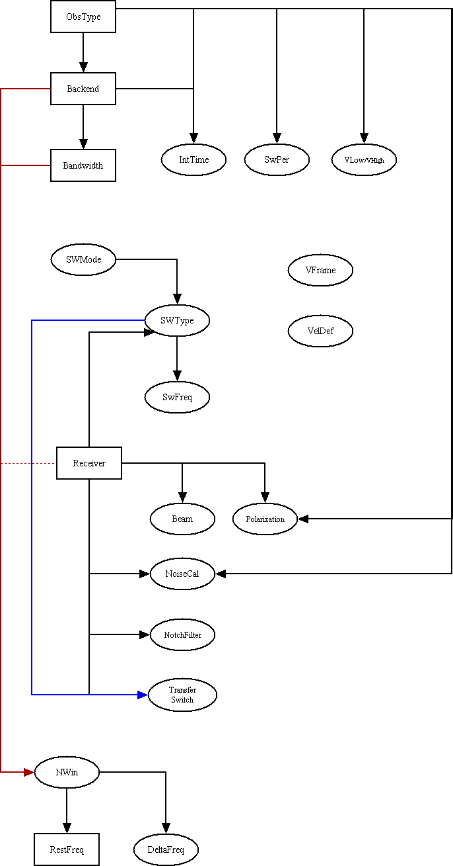
Figure 1: Keyword Dependencies

6.0 Frequency Calculations.
The following summarizes the calculations presented in the memo: “Requirements for Multi-frequency Observing with the GBT”.

Let V1 and V2 be the given range of velocity, with V1 > V2 and V1 = Vhigh , V2 = Vlow .
The conversion to the local frame uses the appropriate formula for the selected velocity definition:

Flocal = fvdef( V, Frest ) [1]

Table 8: Formulas for conversion to local frame
Vdef | Formula
Radio | fvdef(V, Frest) = Frest( 1 - V/c)
Optical | fvdef(V, Frest) = Frest( 1+V/c) ⁻¹
Relativistic | fvdef(V, Frest) = Frest { 1 - (V/c)²}^{1/2}/(1+V/c)
Let Fk = Restfreq, and dF = Deltafreq. For N spectral windows, our configuration keywords will specify Fk[i] and dF[i], the list of rest frequencies and offsets, for each i = 1,N.
Convert the Fk frequencies to the local frame, and add the offsets:
F1[i] = fvdef( V1, Fk[i]) + dF[i]
F2[i] = fvdef( V2, Fk(i]) + dF[i] [2]
Determine the center frequency and total bandwidth:
Fcent = 0.5*(MAX(F2[i]) + MIN(F1[i])) [3]

BWtot = MAX(F2[i]) - MIN(F1[i]) + BW [4]
(where BW is the backend bandwidth keyword value.)
These quantities are used in the following ways:
• The receiver tuning frequency is set to Fcent.
• The LO1 rest frequency parameter is set to FK[1].
• The receiver RF filter (if any) is set to include a range from Fcent-0.5*BWtot to Fcent+0.5*BWtot.
• IF filters in the receiver and IF Rack are set to the narrowest value that includes BWtot.
Given that the primary rest frequency, Fk[1], will not in general be at the center of the IF band, we need to modify the IF center frequency (IF1) in the LO1 manager so that the IF band represented by (Fcent, BWtot) is centered.
Let the nominal IF1 frequency be IF1nom, which has values of 1080 MHz for prime focus receivers, and either 3000 or 6000 MHz for Gregorian receivers. Then set the IF1 parameter in the LO1 manager to:

IF1 = Fcent – Floc0 + IF1nom [for Rcvr8_10 and lower frequency] [5]
IF1 = Floc0 - Fcent + IF1nom [for Rcvr12_18 and higher frequency]

Where Floc0 = fvdef( 0.5*(V1+V2), Fk[1])
Now we can determine the appropriate frequency settings for the LO2 synthesizers. If we define:
Flocal[i] = fvdef( 0.5*(V1+V2), Fk[i] ) + dF[i] [6]
Then
For lower sideband receivers ( for frequencies up to 11 GHz):
LO2[i] = Fcent – Flocal[i] + IF1nom + 10.50GHz - IF3 [7]

And for upper sideband receivers ( for frequencies above 11 GHz):

LO2[i] = Flocal[i] - Fcent + IF1nom + 10.50GHz - IF3 [8]

where IF3 depends on the chosen back end, as listed in Table 9.

Table 9: Nominal Center Frequencies (IF3)
Back End | Frequency (MHz)
ACS-12.5MHz | 468.75
ACS-50MHz | 425
ACS-200MHz | 900
ACS-800MHz | 1200
Spectral Processor | 250
VLBI | 750
BCPM | 400
Radar | 720

7.0 Cabling: Path Finding Through the IF System.
The key to finding the paths through the IF system is the cabling file. We also propose a module quality factor which allows flagging of devices that are substandard or out of service. The actual format or file used to specify a module’s quality file and the implementation of path finding through the system is best left to the next phase of this project and consultation with software developers. We outline a procedure, in general terms, which we hope will convey the requirements.
The possible paths through the system can be regarded as a tree structure (figure 2). This structure is defined by the cabling file and knowledge of the internal structure of the IF Rack, Converter Racks, and Analog Filter Rack. The keywords that drive the path finding process are: Receiver, Backend, Bandwidth, Beam, and Nwin.
The first step is connecting the Receiver beams to the IF Router. This is already implemented in the IF Router manager software, so the only action required is to send the receiver name to the Scan Coordinator which, in turn, sends the receiver parameter value to the IF Router manager, and its inputs will be set correctly. The user will have specified the Receiver and Beam keywords, so the desired input ports of the IF Router will be known.
The next step is routing the LO1 signal to the receiver. The LO1 manager takes care of this in response to the setting of its receiver parameter.
Some of the receivers (Rcvr8_10 and lower frequency) have their signals split to go to two pairs of IF Router inputs. In this case the tree has two branches. Any IF Router input can be connected to one of two optical fiber drivers, depending on the IF Router’s transfer switches. Once an optical driver is chosen, the cabling file contains information concerning which optical receiver will be used. The optical receiver outputs split to four converter modules.
Each converter module can select between four outputs, but these are determined by the Backend and Bandwidth, so there is no branching here. If using the Spectrometer or DCR_AF, the Analog Filter Rack needs to be considered. The choice of AFR input is determined by which converter modules were chosen, and the filter settings in the AFR are determined by the Bandwidth, so there is again no branching. Each AFR module connects to a particular sampler in the Spectrometer, so there is, again, no choice.
Thus for any beam of the selected receiver, there are at most 2x2x4 or 16 possible paths to a backend port.
The software should consider all possible paths and consult the module quality designations to eliminate paths that contain a substandard module. If there is no path with all good modules, we propose an error message will be issued. We leave as an open question at this point exactly how to rate modules and how each path is to be ranked based on the quality designation. For paths that have equal quality the choice will be to select the lowest numbered modules first, for example, choose converter modules 1&5 first, then 2&6, and so on.
The procedure would be to start with the first beam of the first spectral window, search the tree and decide on the path. Then go to the second beam, if any, and continue through however many beams are required. Next, repeat the process for each remaining spectral window. In this way, all paths are found for the specified observing.
This process of path finding is the first step the configuration software must go through. It determines how the IF Router transfer switches are to be set, and how the input switches of the Converter Modules and Analog Filter Modules are set. It identifies which Converter Modules go with which spectral windows, and thus which LO2 synthesizers are set to which frequency.
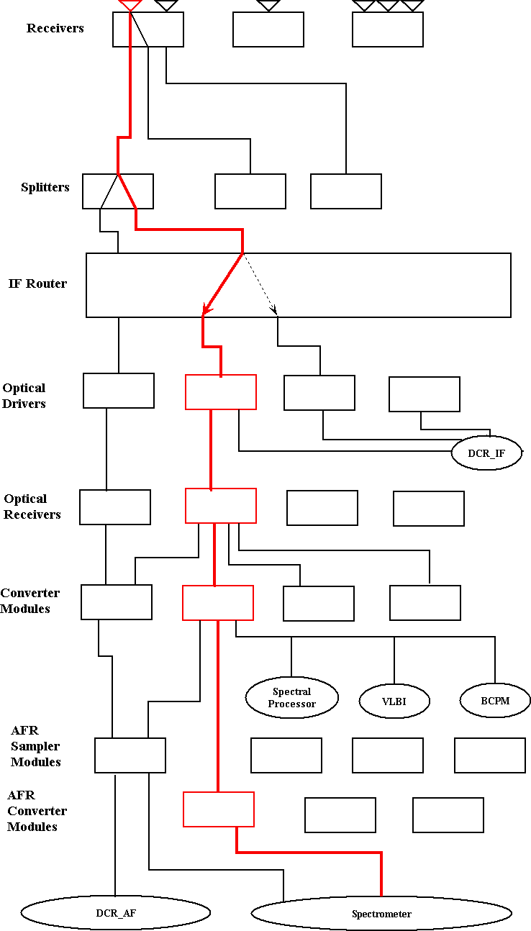
Figure 2: Typical Cabling Diagram for a configuration that uses a slow-speed Spectrometer sampler

